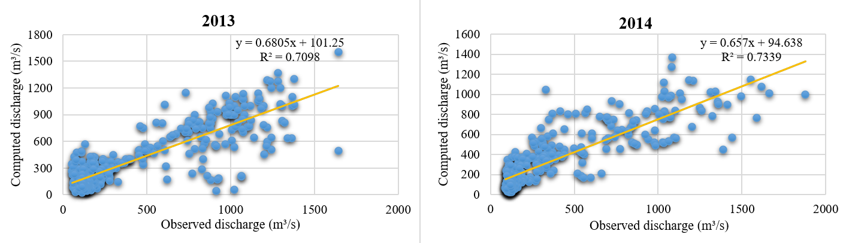 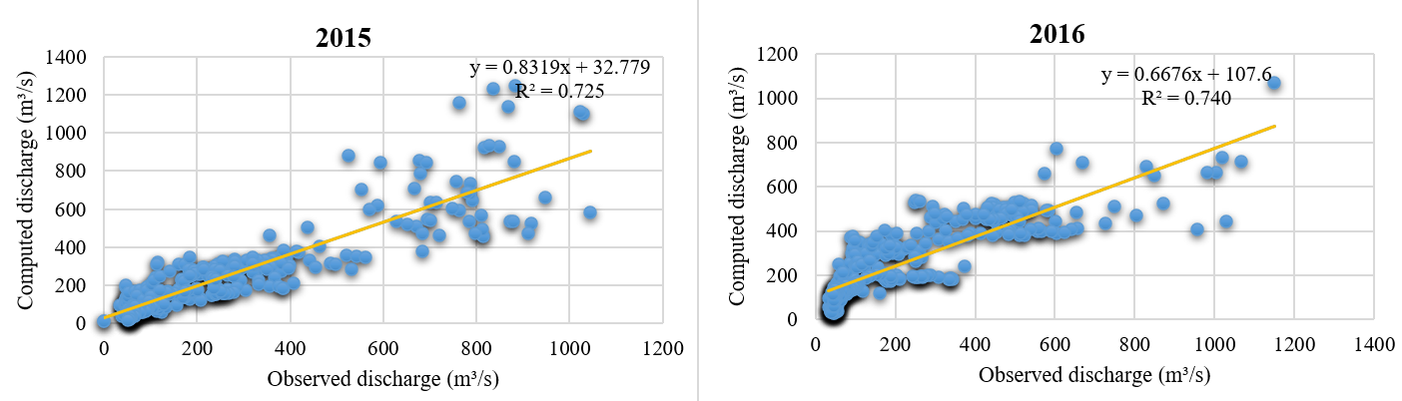 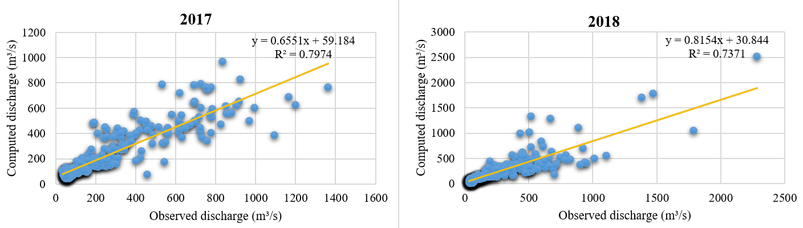

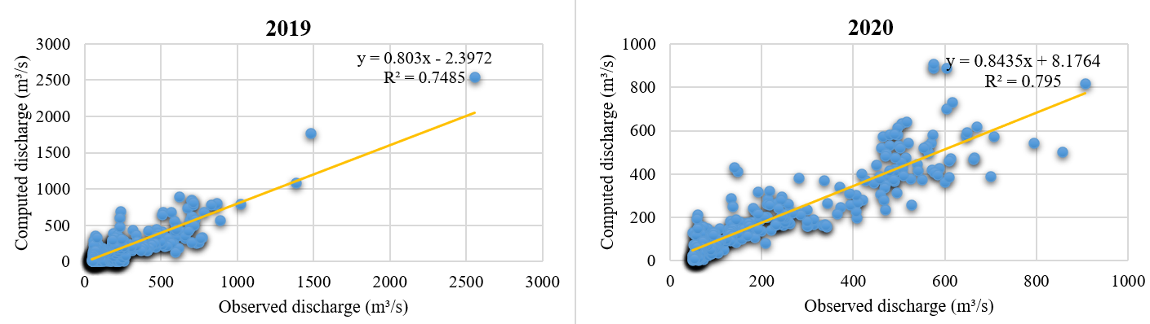

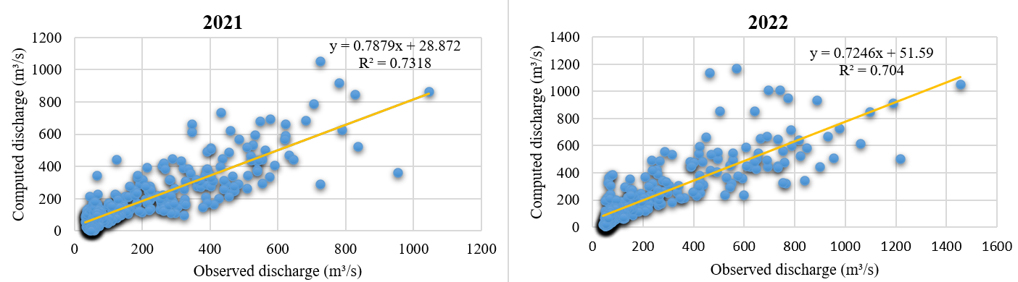

**Figure 7.** Computed and measured daily river discharge in SRM for the year 2013-2022